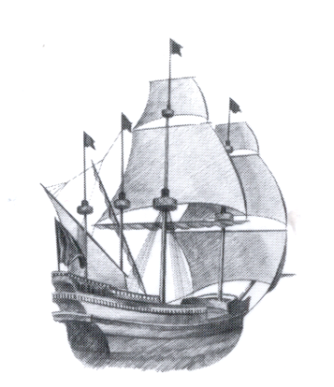
Northeastern New York Conference

Central Atlantic States Association

Of Food & Drug Officials

Presents a Quarterly Meeting

Friday February 9, 2018

New York State Department of Agriculture & Markets;
The Pride of New York Room
10 B Airline Drive; Albany, NY 12205

8:30 am – 9:30 am REGISTRATION

9:30 am – 10:45 am “Injuries Among Food Service Workers”
Julia Zhu
New York State Department of Health
Bureau of Occupational Health and Injury Prevention

10:45 am – 12:00pm “NYS of Rabies”
April Davis
New York State Rabies Lab

12:00pm– 1:00 pm Lunch will be Provided

1:00 pm – 2:00 pm “Weapons of Mass Destruction”
SA Thomas Stewart
WMD Coordinator
FBI Albany Division

To register for this training seminar please send your check, made payable to NENY CASA, and contact information to:

Attn: Joanna Stores
NYS Department of Agriculture & Markets
10B Airline Drive
Albany, NY 12205
(518) 457-5459 Fax (518) 457-8892

Email: joanna.stores@agriculture.ny.gov

Meeting Registration fees: NENY-CASA Members $12.00

Non Members $15.00

****** 2018 Memberships fees are due. Payment can be made at the door.

Dues:

Regulatory Membership $15.00

Associate Membership $35.00

Academic, Student, Retired $10.00

